***DOCTOR APPOINTMENT BOOKING SYSTEM***

**HOME PAGE:**

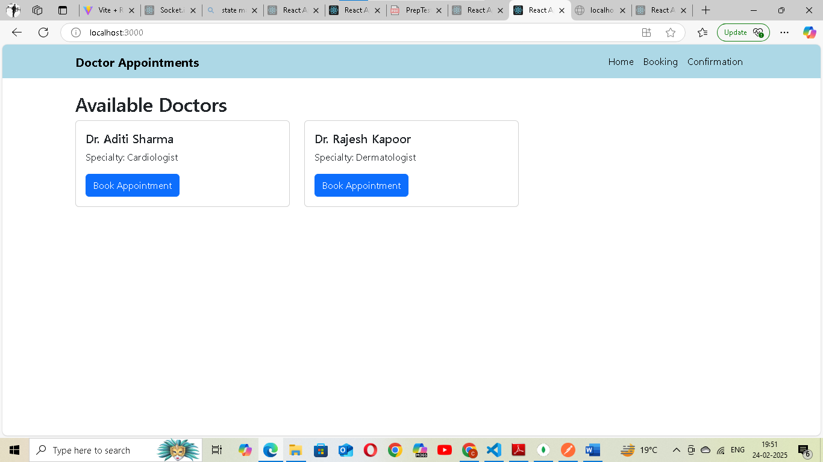

**BOOKING PAGE:**

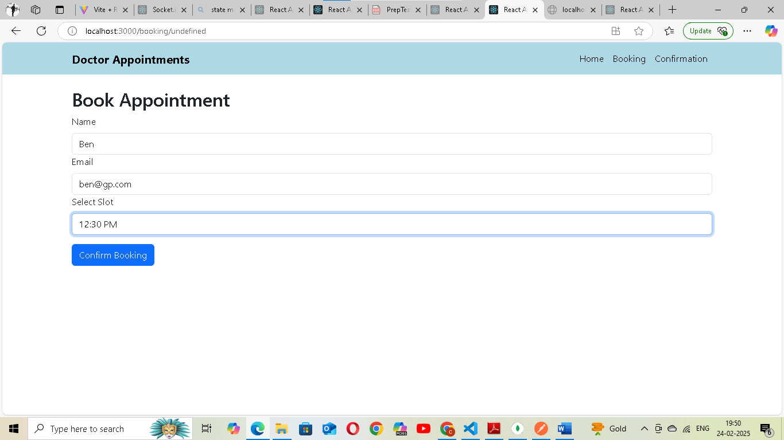

**CONFIRMATION PAGE:**

